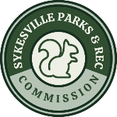
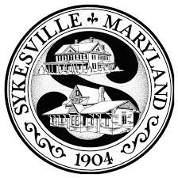

With a 16’ inflatable movie screen and a powerful audio and video system, the Sykesville Parks and Recreation Commission will continue to bring quality-run movie performances to the Town of Sykesville! The 2025 season includes five movies to be shown during the Summer and early Autumn months at Millard Cooper Park. Movies will have wide audience appeal with ratings ranging from G to PG. Sykesville Cinema is the only venue of its kind in the Freedom area and has become a staple within and around our Town.

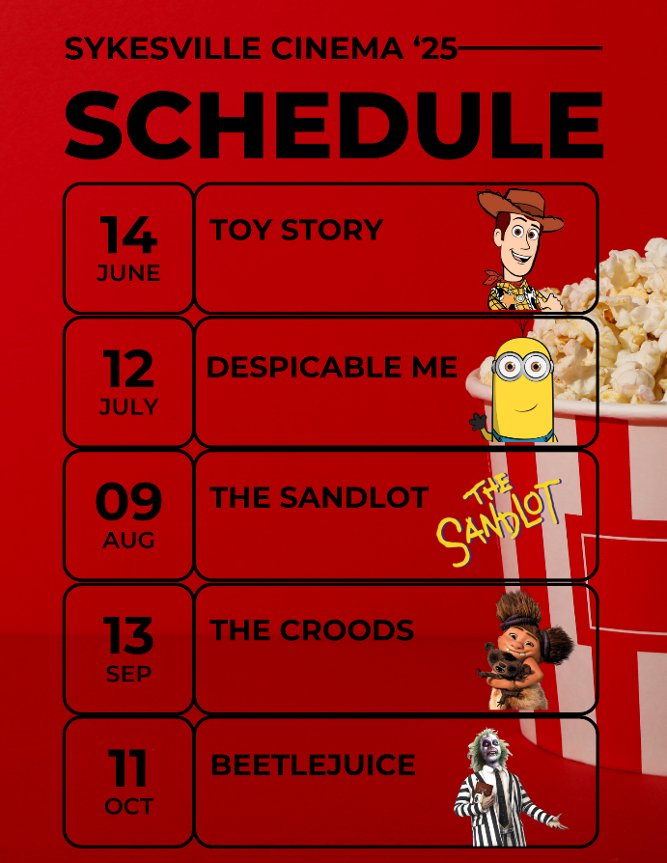


A rolling series of slides or short videos will be shown prior to each movie. These ads will contain sponsorship advertisements as well as promotional items and PSAs from the Town of Sykesville. Each ad will appear a minimum of five times throughout the pre-show. All videos must be over 15 seconds, but under 30 seconds. The sponsor is responsible for their own ads and needs to have them turned into SPARC two weeks prior to each showing. Please make sure that all file formats are supported in PowerPoint.
Sponsors logos will be listed on the Sykesville Cinema movie schedule found on the Town of Sykesville’s website, the SPARC Facebook page and all additional Promotions.

For more information, please contact:
Sykesville Parks and Recreation at parks@sykesville.net
Office: 410-795-8959, Drew Rittenhouse



Bronze Sponsorship - $75 per movie selection
- Toy Story
- Despicable Me
- The Sandlot
- The Croods
- Beetlejuice

Silver Sponsorship - $200
Sponsorship includes the complete 2025 Cinema Series at a greatly reduced bundled rate
- Silver Sponsorship

Gold Sponsorship - $300
Sponsorship includes the complete 2025 Cinema Series PLUS the ability to change advertisement slides for each showing
- Gold Sponsorship

Sponsor Receipt

Sponsor Name: Sponsor Business: Date Received: Amount Paid: Movie(s)/Package Selected: SPARC Member:
Sponsor-provided PowerPoint compatible advertising to be submitted no more than two weeks prior to showing.


_ _ _ _ _ _ _ _ _ _ _ _ _ _ _ _ _ _ _ _ _ _ _ _ _ _ _ _ _ _ _ _ _ _ _ _ _ _ _ _ _ _ _ _ _ _ _ _ _ _ _

Parks and Recreation Use Only
Sponsor Name: Sponsor Business: Date Received: Amount Paid: Movie(s)/Package Selected: SPARC Member:
Sponsor-provided PowerPoint advertising slides to be submitted no later than

