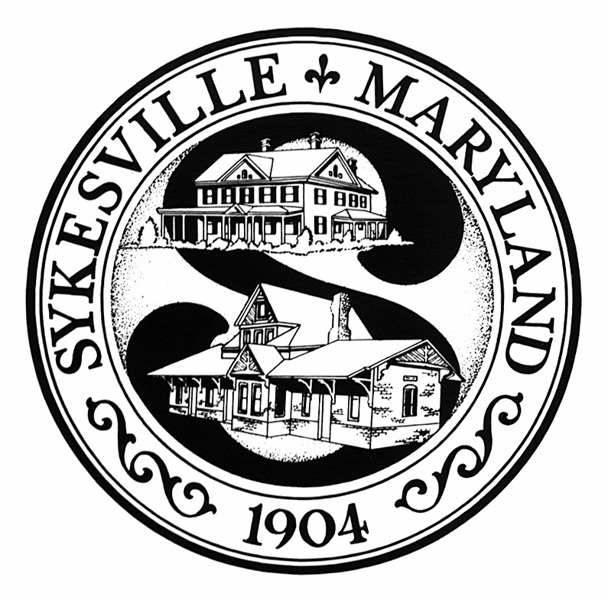
Town House
Ian Shaw, Mayor
Dawn M. Ashbacher, Town Manager
Linda S. Joyce, Town Treasurer
Janice M. Perrault, Town Clerk

App

Town of Sykesville
7547 Main Street, Sykesville, MD 21784
p: 410.795.8959 f: 410.795.3818
www.sykesville.net

APPROVED

OFFICIAL MINUTES OF NOVEMBER 9, 2015 REGULAR COUNCIL MEETING

NO. 15-19

The Council meeting of the Town of Sykesville was held on Monday, November 9, 2015. Mayor Shaw called the meeting to order at 7:00 P.M. in the Council Meeting Room at the Town House. Mayor Shaw led the pledge of allegiance to the flag and a moment of silence.

Present: Mayor Shaw, Council President Keenan, Council members Betz, Bleam, Carter, Link, and True.

Staff: Police Chief Spaulding, Treasurer Joyce and Economic Development Director Colella.

Public Concerns: None

Minutes: October 13, 2015

Motion: Council Member Keenan motioned and Council Member Carter seconded to approve the October 13, 2015 minutes as written. The motion carried unanimously.

Minutes: October 26, 2015

Motion: Council Member Keenan motioned and Council Member Link seconded to approve the October 26, 2015 minutes as written. The motion carried unanimously (5-0-2) with Council Member Bleam and Mayor Shaw abstaining.

Public Safety
Report: Chief Spaulding gave the Public Safety Report. Chief Spaulding commented all went well during the Chili and Beer Festival. Spaulding thanked the Carroll County Sheriff’s Department for providing additional auxiliary police personnel.

Treasurers
Report: Treasurer Joyce presented the Treasurer’s Report for the period ending September 30, 2015.

Motion: Council Member Betz motioned and Council Member Link seconded to approve the Treasurer’s Report. The motion carried unanimously.

Council Committee
Reports:
Historic District Commission – Council member Link stated the Historic District Commission meeting was held on October 27, 2015.
The Commission heard from one applicant. The next meeting is scheduled for November 24, 2015. Councilmember Link also stated three applications have been received for the curator position available at the Gate House Museum.

- Parks and Recreation Committee - Councilmember Carter stated the next meeting is scheduled for November 19, 2015.

- Warfield Development Corporation - Mayor Shaw stated the WDC met on November 4, 2015. Discussion took place regarding removal of materials from an underground storage building. Shaw also stated other topics discussed at the meeting were updates on the contract conditions required before closing. Shaw stated it is hopeful that closing could take place by the end of the year.

- Main Street Association – Council President Keenan reported the Chili and Beer Festival was a success. He listed numerous people who made the event a success. Keenan stated the numerous volunteers helped make the event a success. Keenan stated he will report the final proceeds of the event at the next Town Council meeting. Keenan stated Merry Main Street is scheduled for December 12, 2015. Keenan stated the next Main Street meeting is November 11, 2015.

- Planning and Zoning – Councilmember Betz stated there was not a regular Planning and Zoning meeting this month. Councilmember Betz attended the joint Town/Carroll County meeting that took place on November 4, 2015. Highlights of the meeting were MD Route 32 dualization, gateway signage and the county fiber optic network. The next regular Planning and Zoning meeting is December 7, 2015.

- Streetscape – Councilmember Bleam stated the next Streetscape Task Force meeting is scheduled for November 16, 2015 at the Town House. State Highway will not be present. The Task Force will be meeting with the consultant at that time.

Announcements:
- Military Memorial Dedication will be held on Veteran’s Day, November 11, 2015 in front of the Town Hall. The American Legion Post #223 will conduct a flag raising ceremony.
- Santa’s arrival is set for December 5, 2015 with the assistance of the Sykesville-Freedom District Fire Department. There will be a Christmas tree lighting at Centennial Fountain followed by the showing of “A Charlie Brown Christmas” movie, while the children wait to see Santa.

- St. Nikolaus Day at the Schoolhouse is scheduled for Sunday, December 6, 2015 from 1:00 to 4:00 PM. The event will include holiday crafts, and old world refreshments.
- Merry Main Street in Sykesville will be held on December 12, 2015 at the Town House from 1:00 to 5:00 PM.

New Business:

Presentation from Sykesville & Patapsco Railway and Little Sykes Railroad- Jack Rodriquez, President of the Sykesville and Patapsco (S&P) Railway, presented information on the railway. He stated they are a non-profit 501C3 organization that operates the Pullman car and caboose located downtown. The S&P Railway is also a model railroad club. Their mission is to promote and educate the public about the Town and anything related to its train history. They are volunteer-driven. Rodriquez stated the railway nets around 3,000 visitors a year and with numbers steadily increasing each year. They have increased their hours of operation to coincide with the Town’s Farmers Market and Main Street events. Rodriquez stated the past Halloween night, 1,100 visitors came through the Pullman car. He stated the Town contributes an annual $400 grant to help pay its utilities.

Rodriquez stated he would like to see the S&P Railway grow and improve services. He is hoping a dialog can begin with the Town regarding repairing the brick walkway behind the Main Line Visitor Center and explore ADA compliance to help people see the model trains inside the car. Items of concern are the wooden steps and the Pullman car doorways. The current agreement with the Town requires the railway to perform general maintenance on the cars. It does not mention the grounds or steps maintenance. Cost estimates have not been obtained for the above mentioned improvements. Mayor Shaw thanked the S&P Railway for their dedication to the Town and their commitment to the Town’s history.

Mark Bennett, representative from Little Sykes Railway, presented information about the miniature railroad train ride for children located on Sandosky Road. The train is owned by the Town of Sykesville and is open to the public free of charge. Highlights of the 2015 season were:
- Open 23 of the 27 weekends this year
- More than 1,500 rides given
- 514 volunteer hours
- Approximately $2,000 in donations received

Bennett stated the recent State of Maryland inspection required several improvements be completed. He stated most of the improvements have been completed by volunteers. In addition, Bennett stated for 2016, the Little Sykes Railroad plans to improve advertising and web presence, seek additional volunteer drivers, re-panel the station office and improve storage. Bennett also requested a Town inspection of the storage building for structural integrity due to sagging of the doors.

Mayor Shaw thanked Bennett for the report and the opportunity to address the needs when the next funding period arrives. The council thanked Mr. Bennett and all the volunteers for their dedication.

- Town Decorating Contest – Each year the Mayor and Council host a holiday house decorating contest throughout the town. The Mayor and Council agreed on December 15, 2015 for judging to take place. There is a $175 budget amount allocated for contest winner signs. Councilmember Carter will order the signs.

Adjourn: There being no other business to come before the Council, Council Member True motioned and Council Member Bleam seconded to adjourn the meeting at 7:57 p.m.

The motion carried unanimously.

Respectfully Submitted by
Linda Joyce
Treasurer

